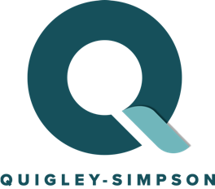

Testimonials for our Multicultural Marketplace

“Multicultural marketing is the biggest growth opportunity we have in front of us. By working with Quigley-Simpson and the Cultural Accelerator Marketplace (CAMP), we have been able to achieve performance and multicultural investment tools.”
- Fortune 50 Marketer

“Quigley-Simpson has been on the forefront of building private marketplaces with outsized performance.”
- Greg Williams, Audigent

